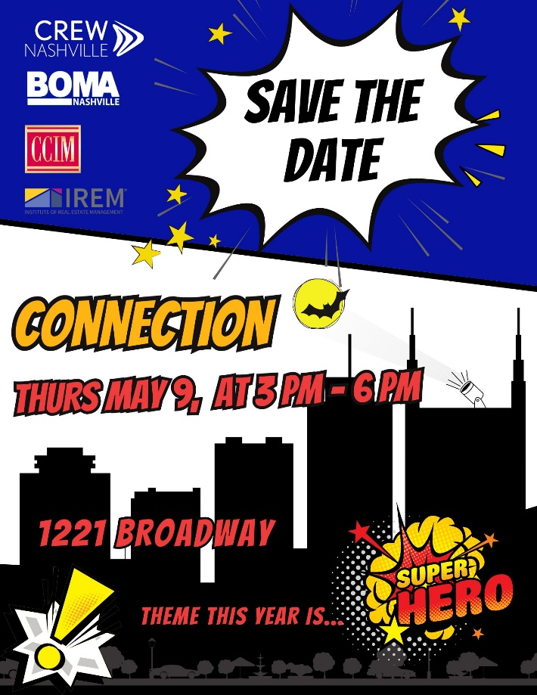

We are very excited to announce that the 2024 Connection will be held at the BRAND NEW ONE 22 ONE

Thursday, May 9th, 2024
1221 Broadway
3:00 pm- 6:00 pm

Thank you for considering a sponsorship for The Connection. The Connection is one the largest networking events for Real Estate Professionals in Nashville. It is also a Fundraising Event for CREW, BOMA, CCIM, & IREM.

Once expenses are paid, the four organizations split the proceeds and use those funds for their charitable organizations, scholarships for continuing education classes for their members, scholarships for college students studying the Real Estate profession, and as a supplement to their operating budgets. As a Networking Event, it is an opportunity to connect with approximately 300 other Real Estate Professionals in a fun and relaxed environment.

We hope you take this opportunity to support this event, and more importantly attend The
Connection. Sponsorship information is attached. Sincerely,
2024 Connection Committee Member

2024 SPONSORSHIP FORM The CONNECTION

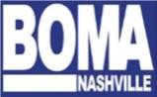
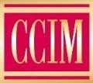
Hosted by

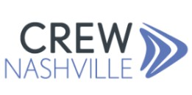

Please check next to the chosen level of sponsor participation or register online at www.crewnashville.org:

 | Sponsor Amount | Benefits
Batman | $7,500 | • Recognition with logo on invitations as event sponsor, media pieces, and day of event media  • 15 event tickets, on site exposure day of event
Superman | $3,000 | • Recognition with logo on invitations as event sponsor, media pieces, and day of event media  • 8 event tickets
Wonder Woman | $2,000 | • Recognition with logo on invitations as event sponsor, media pieces, and day of event media  • 6 event tickets
Black Panther | $1,000 | • Recognition with name on invitations and day of event media  • 4 event tickets
Black Widow | $500 | • Day of event media  • 2 event tickets
Thor | $75 | • Individual Ticket for entry to event

To pay online, please visit crewnashville.org/events

If you need an invoice, please fill out the below information:
Company Name: ___________________________________ Contact Person: __________________
Phone Number: ____________________________________
E-mail: _________________________________________
Please designate the names of those attending as your pre-paid guest (see above chart for the number of tickets per sponsorship level):

Enclosed is my check amount of $

Please return checks and sponsorship form to: CREW/Connection PO Box 1882
Brentwood, TN 37024

with an email copy to Andrea Miller amiller@proimagefacilitysolutions.com
Please call 615-638-0277 with any questions.

